PRACTICAL 4A: SEQUENTIAL CIRCUITSRonak Mehta (MHTRON001)

Plagiarism Declaration1. I know that plagiarism is wrong. Plagiarism is to use another’s work and pretend that it is  
one’s own.  
2. I have used the IEEE convention for citation and referencing. Each contribution to, and  
quotation in, this practical report from the work(s) of other people has been attributed and has  
been cited and referenced.  
3. This practical report (including circuit diagrams and code) is my own work.  
4. I have not allowed, and will not allow, anyone to copy my work with the intention of passing  
it off as their own work.  
5. I acknowledge that copying someone else’s code, schematics or report, or part of it, is wrong,  
and declare that this is my own work.

15-05-2018  
Signature Date

Solutions

PART 1:

(a)

The system has 4 states namely 2, 4, 6 and 8.

Number of bits == (log24 = 2) == Number of D-Flip Flops in the system

|  |  |
| --- | --- |
| States | State Number |
| 2 | 00 |
| 4 | 01 |
| 6 | 10 |
| 8 | 11 |

Present State/Next State Diagram

|  |  |  |  |  |
| --- | --- | --- | --- | --- |
| INPUT | PRESENT STATE | | NEXT STATE | |
| I | Q1 | Q0 | D1 | D0 |
| 0 | 0 | 0 | 0 | 1 |
| 0 | 0 | 1 | 1 | 0 |
| 0 | 1 | 0 | 1 | 1 |
| 0 | 1 | 1 | 0 | 0 |
| 1 | 0 | 0 | 1 | 1 |
| 1 | 0 | 1 | 1 | 0 |
| 1 | 1 | 0 | 0 | 0 |
| 1 | 1 | 1 | 0 | 1 |

(b) Equations from Karnaugh Maps

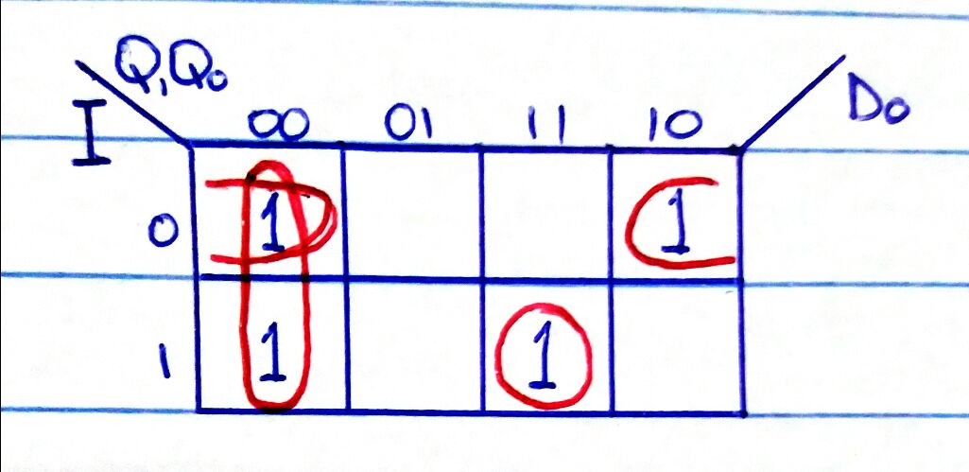

D0 = ( . ) + () + (I . Q1 . Q0)

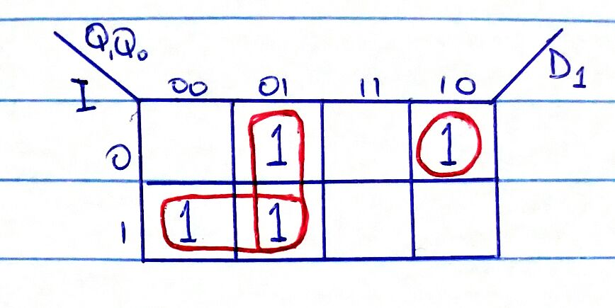

D1 = ( . Q0) + (I . ) + ()

Table for Output Logic expression

|  |  |  |  |  |  |
| --- | --- | --- | --- | --- | --- |
| **PRESENT STATE** | | **OUTPUTS** | | | |
| **Q1** | **Q0** | **O3** | **O2** | **O1** | **O0** |
| 0 | 0 | 0 | 0 | 1 | 0 |
| 0 | 1 | 0 | 1 | 0 | 0 |
| 1 | 0 | 0 | 1 | 1 | 0 |
| 1 | 1 | 1 | 0 | 0 | 0 |

Expressions for the Output

O3 = Q1 . Q0

O2 = Q1 ⊕ Q0

O1 =

O0 = 0

(c)

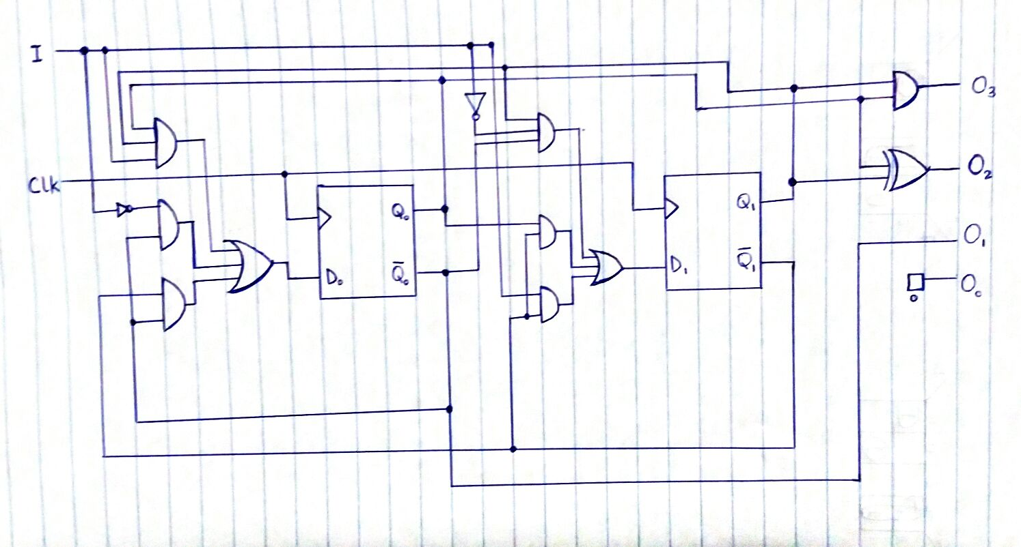

d) Screenshot of Circuit diagram from Logisim

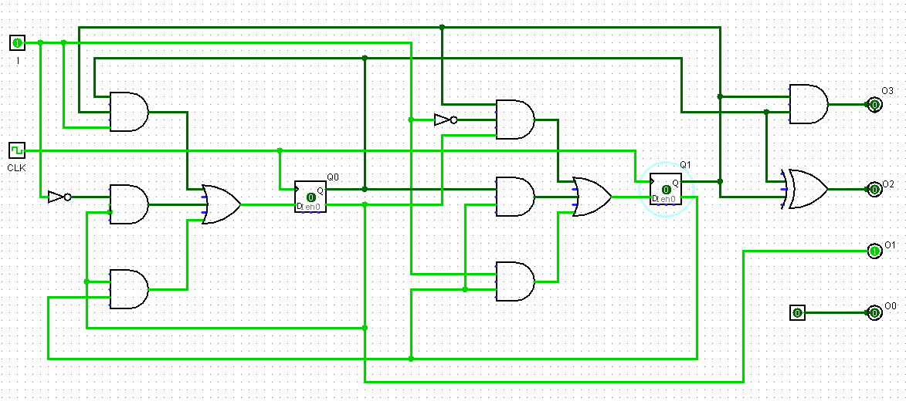

**PART 2:**

(a)

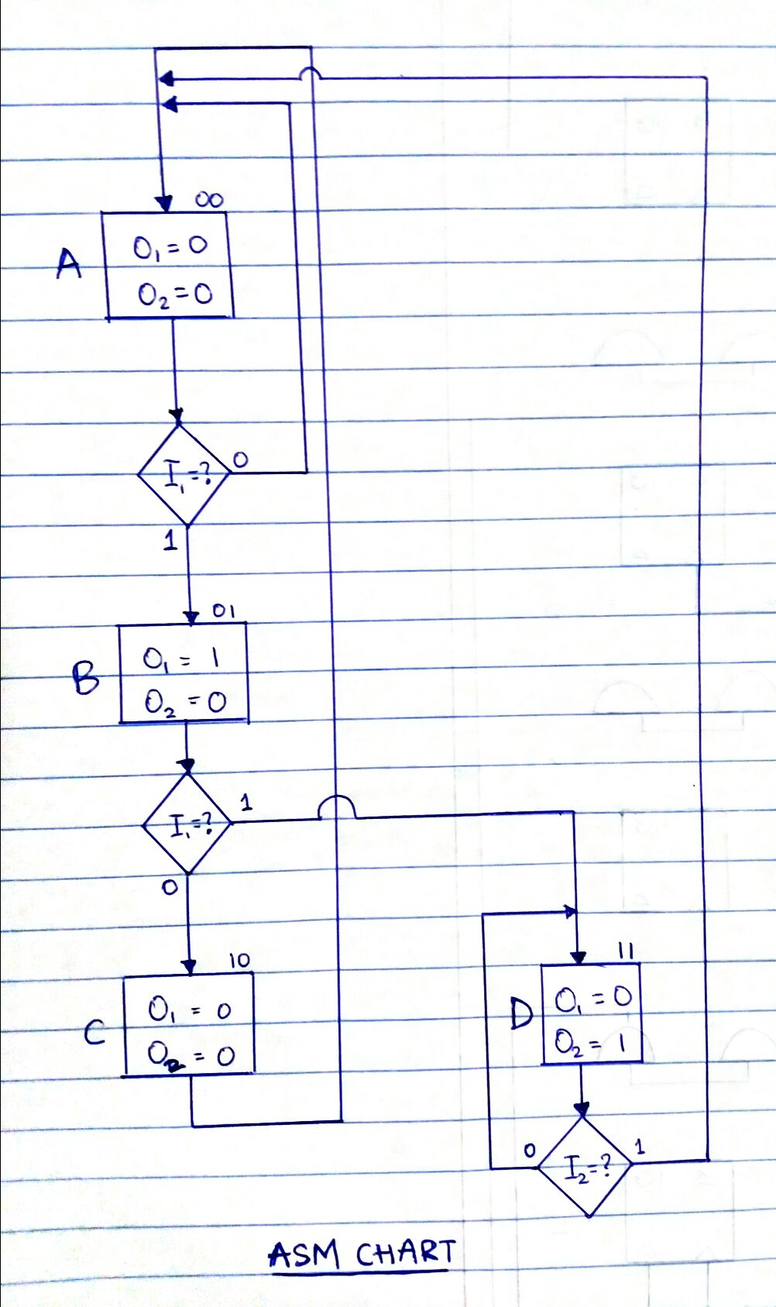

(b)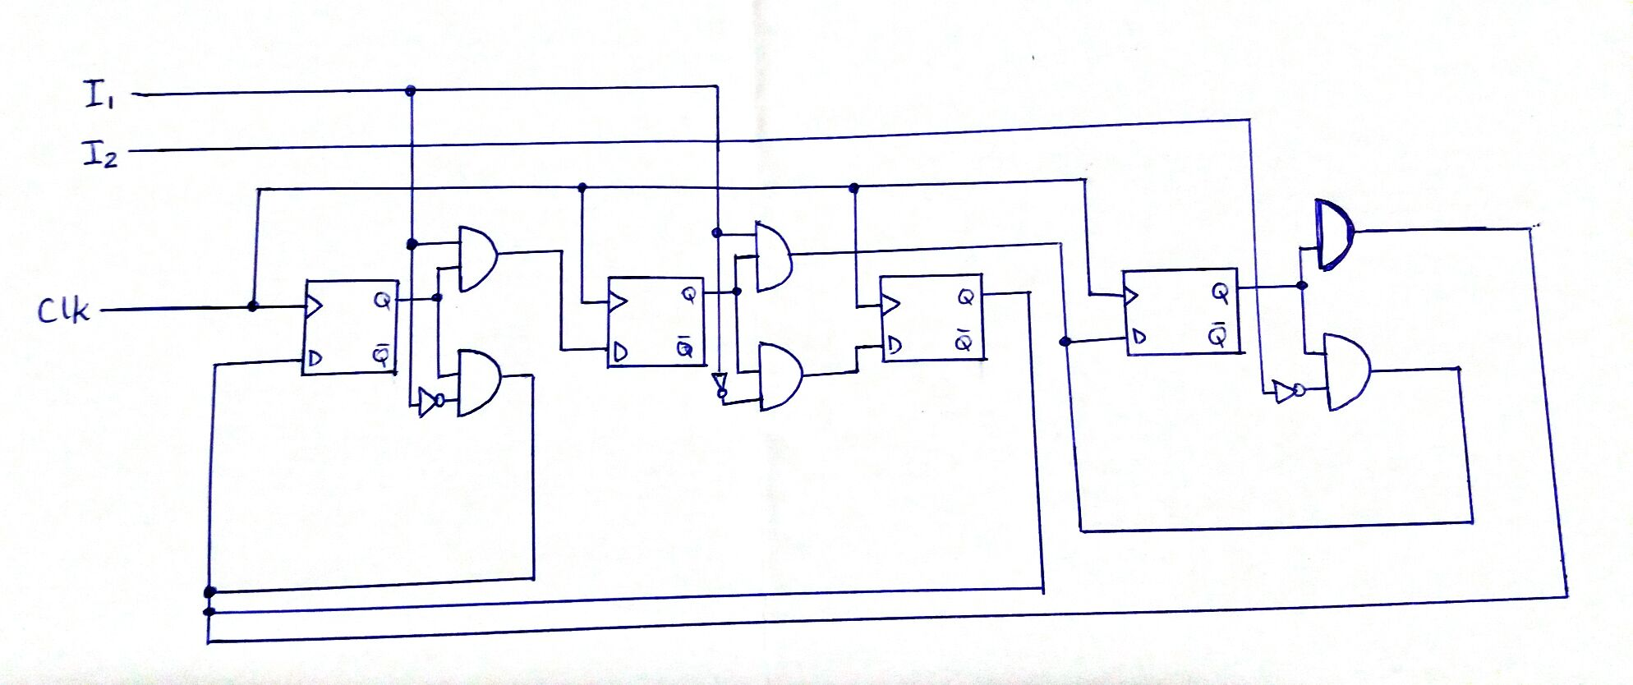

(c) Screenshot of circuit diagram from Logisim

